Welcome To Scribbles
https://pgcpsmdc.scriborder.com/family

- Type the link.

- If the parent is a non-English speaker, they can choose their language.
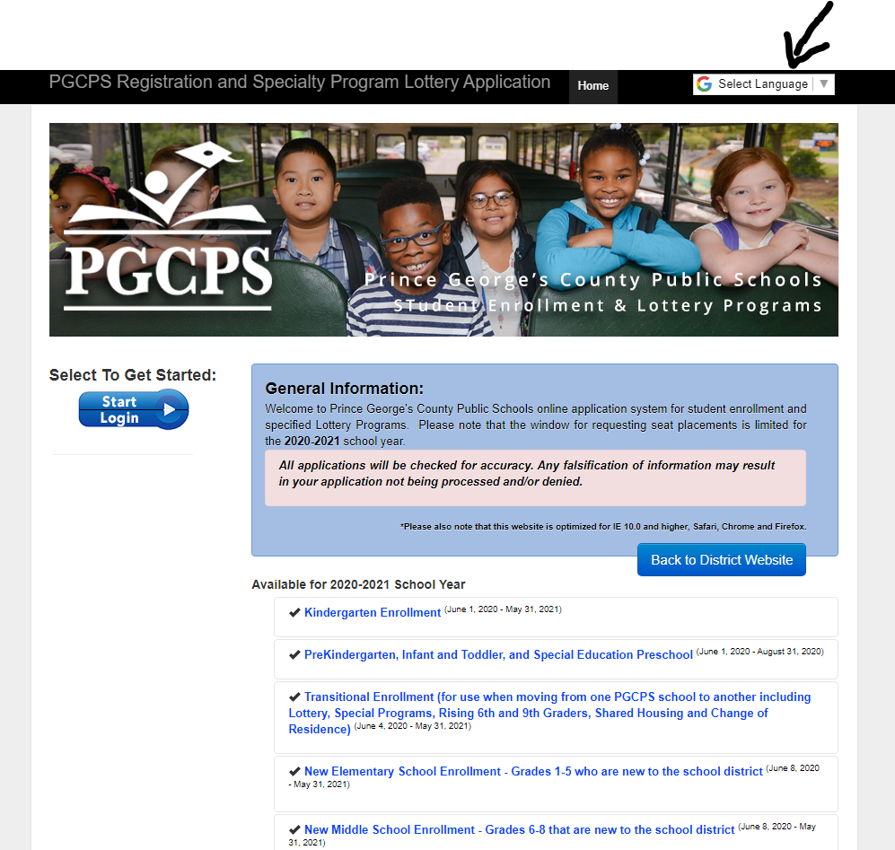

- Click on the start login.
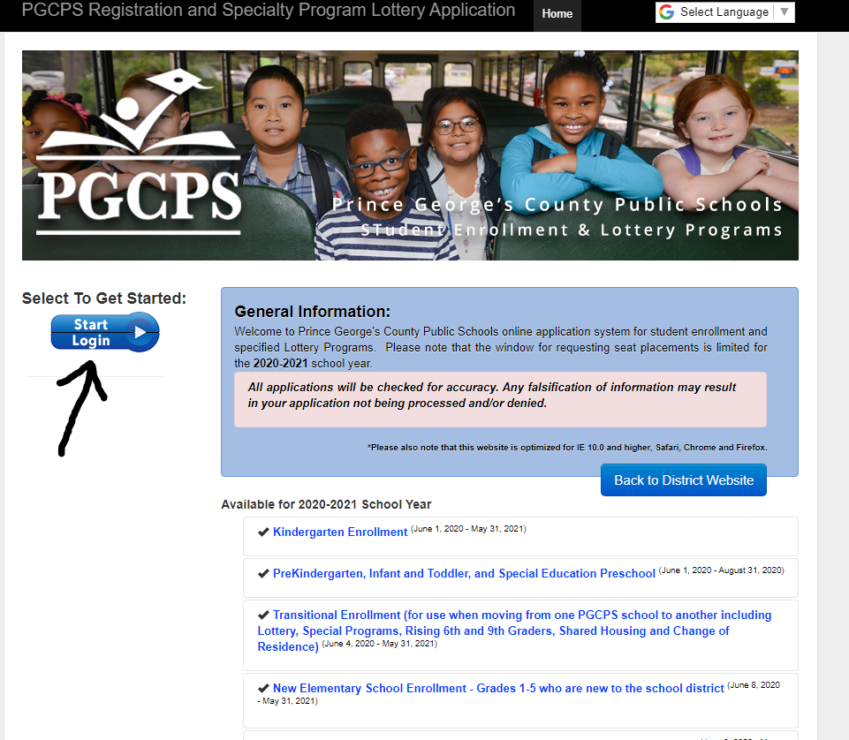

4. Parent will then create an account.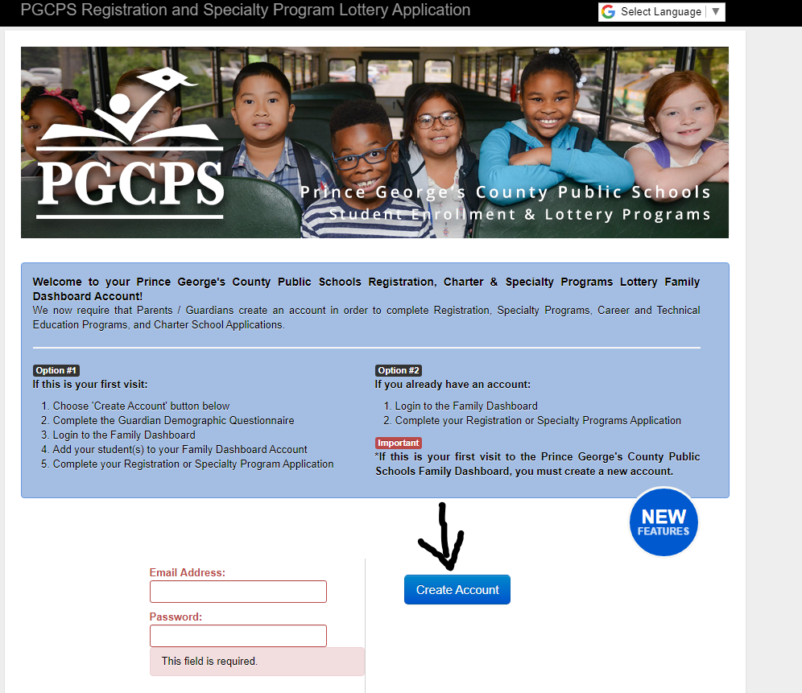

5. Parent MUST complete all requested information.
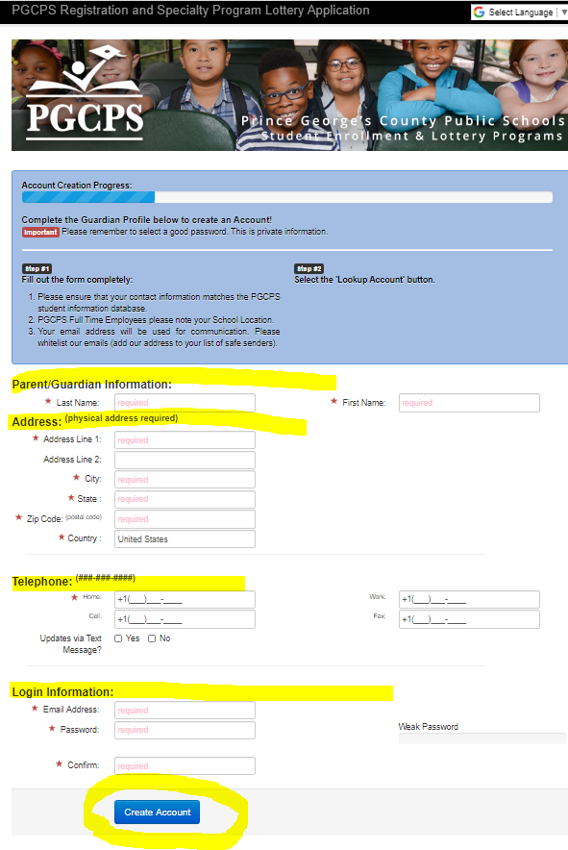

6. Once the parent has created the account. They can login using their email and password.
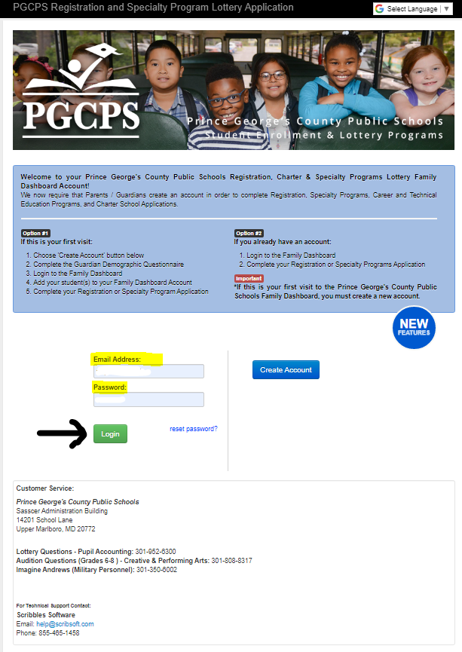
7. Parents should then will follow the directions and fill out all the information. If any information is missing, the system will not allow you to proceed.

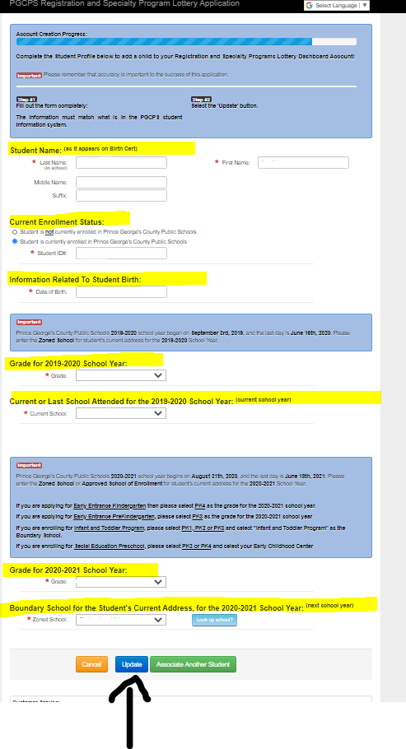
8. Once they have completed filling out the students’ information, the system will then take them back to a previous page. Click on “Begin Registration.” Parents should read and follow all instructions.
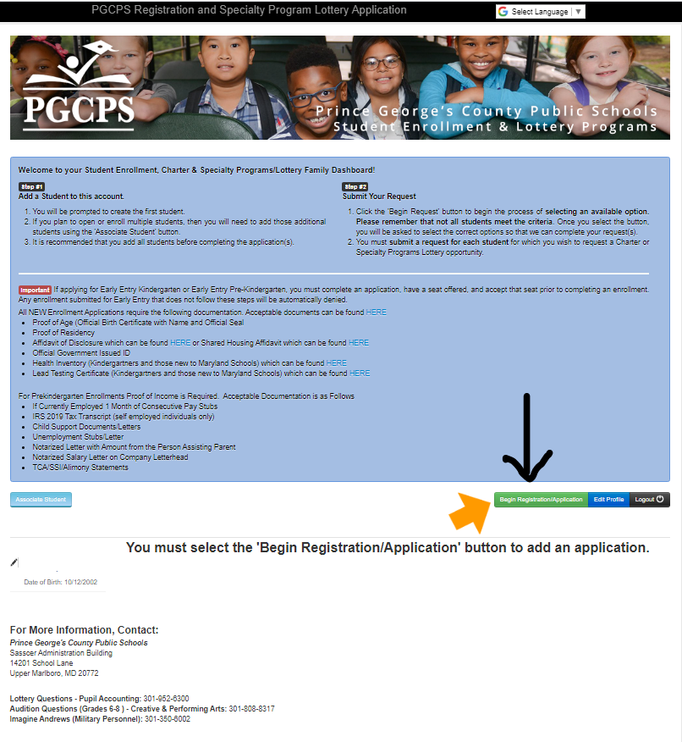

All requested documents should be uploaded to the Scribbles link by parents.

After all documents have been reviewed by the School Registrar, parents will receive an email indicating that it has been accepted and their student is enrolled or parents will receive an email stating that it has been denied (along with an explanation for denial) indicating their student is not enrolled.

